 | Our reference no.: | 23/01583-1
Ms Fatma Sahin, Mayor of Gaziantep President of the Union of Municipalities of Turkey Mr Hayri Baraçli Secretary General of the Union of Municipalities of Turkey | Value/Code:
 | Our reference name:
 | Your reference no.:
 | Document date: | 08.02.2023

Earthquake in Turkey - Condolences

Dear President,
Dear Secretary General,

We are following the tragic news of the earthquake in the Turkish-Syrian border region with deep concern.

On behalf of the Norwegian Association of Local and Regional Authorities and all Norwegian local and regional governments, I send my most sincere condolences to you. Our thoughts are with the families of the victims and with the people of Turkey who have lost loved ones. I am sending warm thoughts to all those who have been injured or affected.

Yours sincerely,
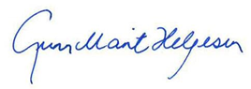
Gunn Marit Helgesen
President of the Norwegian Association of Local and Regional Authorities

